Contents

DEPLOYMENT STEPS: 1

BUIDLING THE PROJECT: 1

EXAMPLE DEPLOYING ON FIREBASE: 2

# DEPLOYMENT STEPS:

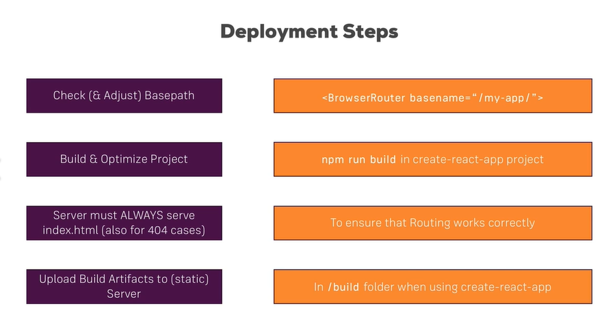

# BUIDLING THE PROJECT:

RUN: npm run build

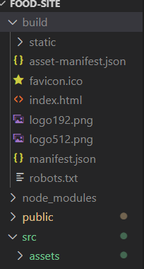

# EXAMPLE DEPLOYING ON FIREBASE:

RUN THIS IN YOUR TERMINAL:

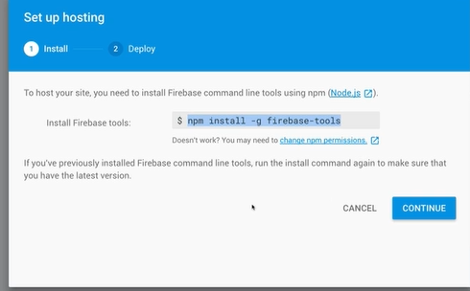

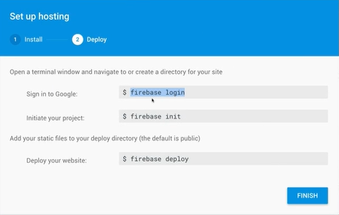



TO DEPLOY:

* firebase deploy